Bug ID: PROD_BUG_01
Title: Add to Cart Button Missing for Some Products
Module: Products Page
Environment: Chrome (Windows)
Severity: Medium
Priority: High

Steps to Reproduce:
- Open Demo Web Shop application.
- Navigate to the Products section.
- Observe all displayed products.
- Check availability of the “Add to Cart” button.

Expected Result:
Every product should be displayed along with the “Add to Cart” button.

Actual Result:
Some products such as “Fiction EX”, “Science” and many other products do not display the “Add to Cart” button.
Attachment:
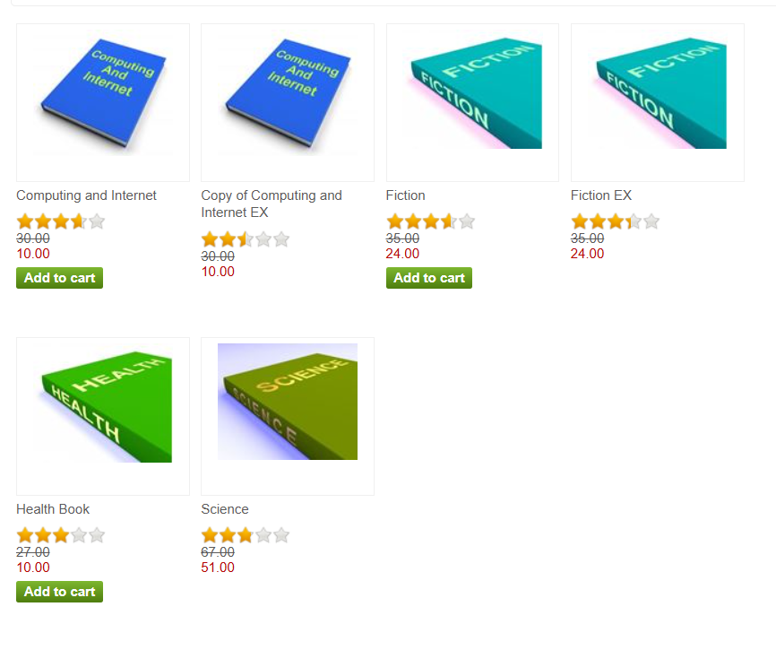
Bug ID: PROD_BUG_02
Title: Add to Wishlist Button Missing for Multiple Products
Module: Products Page
Environment: Chrome (Windows)
Severity: Medium
Priority: High

Steps to Reproduce:
- Open the Demo Web Shop application.
- Navigate to the Products section.
- Observe the displayed products.
- Check for the “Add to Wishlist” button.

Expected Result:
All products should contain the “Add to Wishlist” button since add to wishlist function is added to the site.

Actual Result:
The “Add to Wishlist” button is missing for all products.
Attachment:
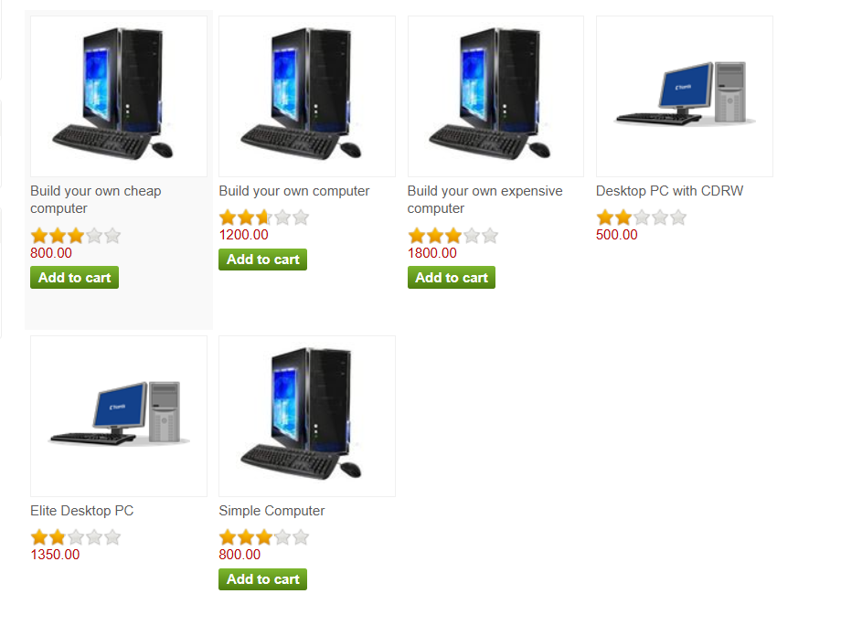
Bug ID: PROD_BUG_03
Title: No Direct Remove Option Available After Adding Products to Cart Degrading User Experience
Module: Shopping Cart / Product Page
Environment: Brave (Windows)
Severity: Medium
Priority: Medium

Steps to Reproduce:
- Open the Demo Web Shop application.
- Add any product to the cart.
- Observe available cart options after adding the product.
- Try removing the product directly from the product page or mini cart.

Expected Result:
Users should be able to remove products directly from the product page or mini cart without needing to navigate to the shopping cart page.

Actual Result:
No remove option is available directly after adding products to the cart. Users are required to visit the shopping cart page to remove items, which creates unnecessary navigation and degrades user experience.
Attachment:


